Report on the findings of the HCPC In Focus feedback survey 2015
- Background
  - The HCPC external-facing electronic newsletter, HCPC In Focus, was launched in November 2005, to promote relevant news and information to our registrants and stakeholders. During its time there have been many developments to the design, content and means of distribution, but we aim to continue these improvements to ensure the newsletter is as relevant as possible to its readers.
  - From 5 June – 17 July 2015 we conducted an electronic survey to collect feedback from our readers. Questions covered the relevance and amount of content, frequency of distribution, areas for future development and general feedback. We promoted the survey in the June issue of HCPC In Focus and received 157 responses.
  - Below is a breakdown of our findings and a summary of potential future developments.

- Breakdown of respondents
  - Of the 157 people that completed the survey, 148 were registrants, six were not registered and three refrained from answering the question.
  - There was a good mix of responses from all our professions, except clinical scientists. Below is a breakdown by profession of the registrants that completed the survey.

Arts therapists | 1.31% (2)
Biomedical scientists | 6.54% (10)
Chiropodists / podiatrists | 7.19% (11)
Clinical scientists | 0% (0)
Dietitians | 3.27% (5)
Hearing aid dispensers | 1.31% (2)
Occupational therapists | 16.34% (25)
Operating department practitioners | 4.58% (7)
Orthoptists | 2.61% (4)
Paramedics | 9.8% (15)
Physiotherapists | 7.84% (12)
Practitioner psychologists | 5.23% (8)
Prosthetists / orthotists | 0.65% (1)
Radiographers | 7.19% (11)
Social workers in England | 20.92% (32)
Speech and language therapists | 5.22% (8)
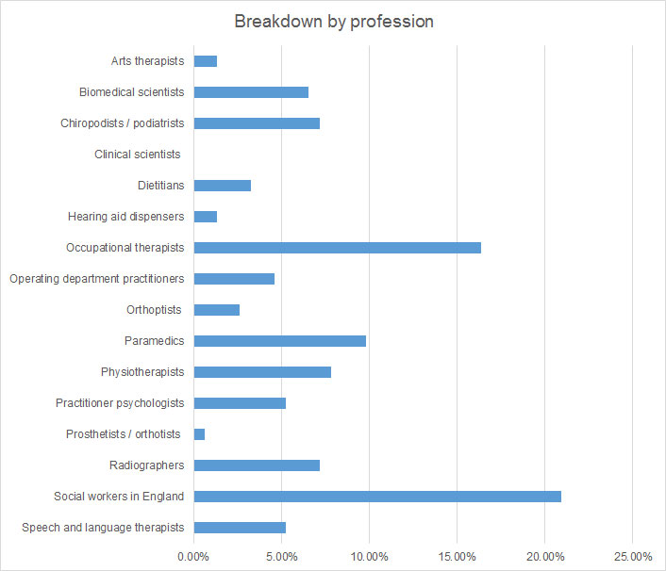

- Executive summary
  - We received a good response to the survey from across all but one of the 16 HCPC-regulated professions. The responses will provide a good starting point for future developments to the newsletter.
  - We will review the many suggested articles and try to cover off relevant items over coming issues. It is also clear from the feedback which existing articles are most popular and we will continue to develop these. Continuing professional development (CPD) specifically was a recurring theme that readers wanted more information on. We will look into how we can extend the effectiveness of existing CPD articles, whilst looking at new ways to cover the topic.
  - As there was an overwhelming demand for one-off special editions around key pieces of news, this is a feature we are keen to implement. We are currently looking into relevant topics that we could cover in the near future.
  - There were mixed views with regards to profession-tailored content, with some preferring to receive more general HCPC news. As such, there are no immediate plans to provide this option, although we will look into this in the future, whilst considering some of the suggested articles in a broader context.
  - The survey was also useful in identifying aspects that we should keep as they are. The amount of content for example was broadly considered about right. We will therefore aim to keep this roughly the same, only increasing it if there is key news that needs to be covered.
  - In terms of frequency of distribution, quarterly was the slightly more popular option. However, if we changed to quarterly it could present the potential issue that time sensitive information, such as consultations, could be missed. Alternatively, if the newsletter were monthly some issues may contain considerably less news than others. Due to these reasons, and the almost even split, frequency of distribution will remain as bi-monthly, though we will continue to review this moving forward.
  - We would like to take this opportunity to thank everyone that took the time to complete the survey. Your views will help to structure the future development of HCPC In Focus.

- Preferred existing content
  - Of the existing content in HCPC In Focus, the most popular topic was information on renewal and CPD, receiving 81.43 per cent. Other popular topics were information on new publications and guidance (64.29%), information on policy consultations (46.43%) and our Focus on articles, where we take an in depth look at a specific regulatory topic (40%). Respondents also mentioned that articles on new developments such as our mobile app were useful.
  - Below is a breakdown of all the responses.
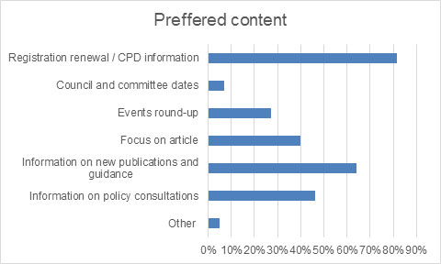

- Potential future content
  - We received 24 suggestions for potential future content. Five of these were on CPD, including wanting feedback from those that have been through the process and a countdown to audit. We currently have an article in each issue which flags the professions that are going through CPD, signposting our information and guidance. We will however look at other ways to promote our existing CPD resources, whilst also looking at potential new initiatives.
  - We also received five requests for information on our fees, two requests to highlight opportunities to get involved with the work of the HCPC and two suggestions for a Meet the Council article. We included a Focus on fees article in June 2015 and have a recruitment article whenever partner opportunities become available. In terms of a Meet the Council article, we will include a welcome article for our new Chair of Council in the August 2015 issue and will consider future articles introducing Council members, as well updates on Council meetings.
  - The remaining suggestions are listed below. Some of these are already covered and some were not appropriate to regulation, but we will look at the potential for incorporating others in future issues.

- A focus on the professions regulated by the HCPC
- Potential regulation of non-registered health care workers
- How to claim back tax on registration fees
- Promoting registration
- International registration
- Changes to legislation
- An awards section for good practise
- Updates on drug guidelines
- Book reviews
- A link to our website

- Amount of content in the newsletter
  - When asked whether there was enough content covered in HCPC In Focus, 73.72 per cent of respondents thought there was the right amount. 22.63 per cent thought that there was not enough content, whereas only 3.65 per cent thought there was too much content.
  - We therefore feel that the amount of content we cover is adequate, though we will look at the potential for adding more content if there are relevant subjects that need to be covered.

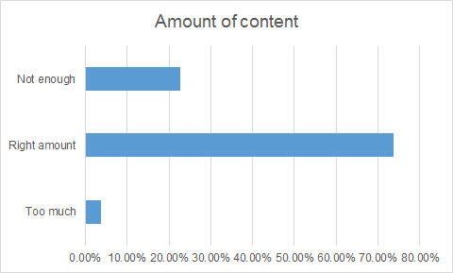

- Frequency of distribution
  - There was an almost even split of opinion on how frequently HCPC In Focus should be sent out to subscribers. The most popular choice was quarterly with 36.64 per cent of votes. Monthly received 33.59 per cent of votes and bi-monthly, which is how regularly it is currently sent out, got 29.77 per cent of votes.
  - Although quarterly was the slightly more popular option, if we changed to this frequency it could present the potential problem that time sensitive information, such as consultations, could be missed. Alternatively, if the newsletter were monthly some issues may contain considerably less news than others.

  - For these reasons, and considering the almost even split between the options, for the time being we will continue to send the newsletter out on a bi-monthly basis, though we will continue to review this moving forward.

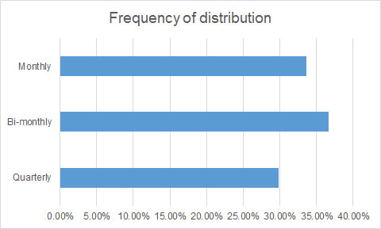

- One-off special editions of HCPC In Focus
  - There was an overwhelming demand for one-off special editions of HCPC In Focus, with 95.52 per cent of respondents saying that they would want to receive this if there was relevant news. As such, we will be looking at potential special editions in the future.

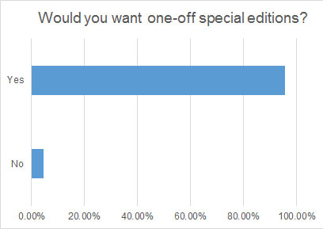

- Tailored content by profession
  - We asked respondents if they would like to receive tailored content by profession. Interestingly, almost a third of respondents (31.34%) did not want tailored content, preferring to receive general information about all HCPC-regulated professions.
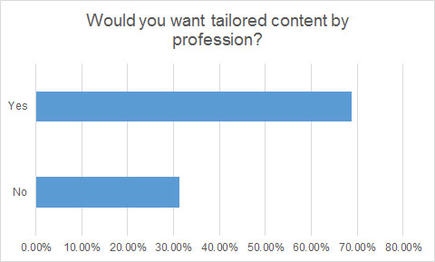
  - Respondents suggested a range of topics that would be of interest, including:

- Profession-lead improvements;
- HCPC collaboration with professional bodies;
- updates to standards and policy;
- FTP case studies;
- examples of CPD from registrants of a specific profession;
- training events and online workshops;
- wider NHS and policy changes impacting a profession;
- essential updates for a profession; and
- a mix of both general and profession-specific information.

  - Although there are no immediate plans to provide profession-tailored content, we will look into the possibility in the future. Some of the suggested topics could be covered on a profession-wide basis and we will consider these for future issues.

- Forwarding the newsletter
  - Although the majority of respondents (74.64%) did not forward the newsletter on to others, just over a quarter did, which extends the reach of HCPC In Focus.

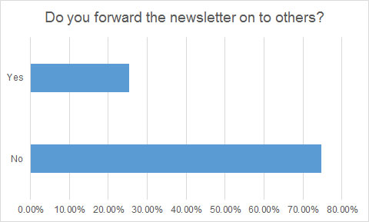

- Other comments
  - We asked respondents if they had any other comments that they would like to make and received contrasting views about the new format of the newsletter. Some felt the new version lacked the depth of information and its content was dry, whereas others thought that it was a useful information tool, with well written articles and useful links. Others preferred having a downloadable version of the newsletter, and as such we have now created a pdf version, which will continue to be housed on our website when the email version is sent out.

- Next steps
  - The survey proved a useful tool in gathering information on the views of our readers. There are several changes that we now intend to make to the newsletter based on the feedback, which are listed in the executive summary.

